**Solutions and Screenshots**

1. File - 1_edge_filter.ipynb.

After applying edge filter and Relu operation. Image[2] is included in the folder.

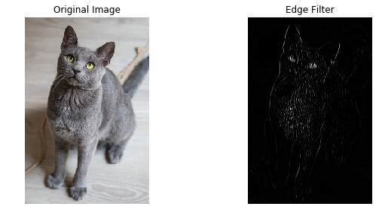

**2.4.**

**one convolutional layer**

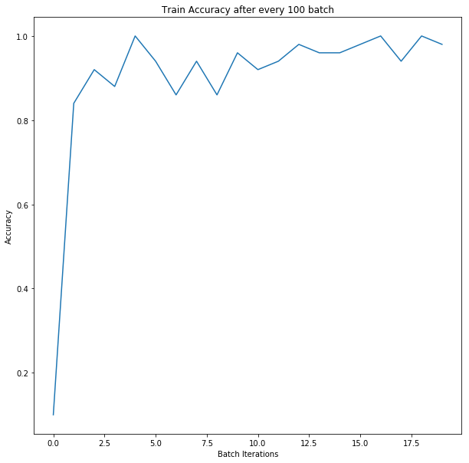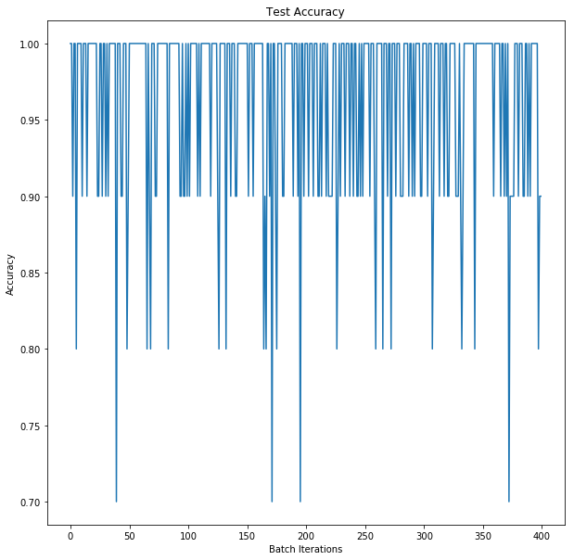

** **

**Two convolutional layers**

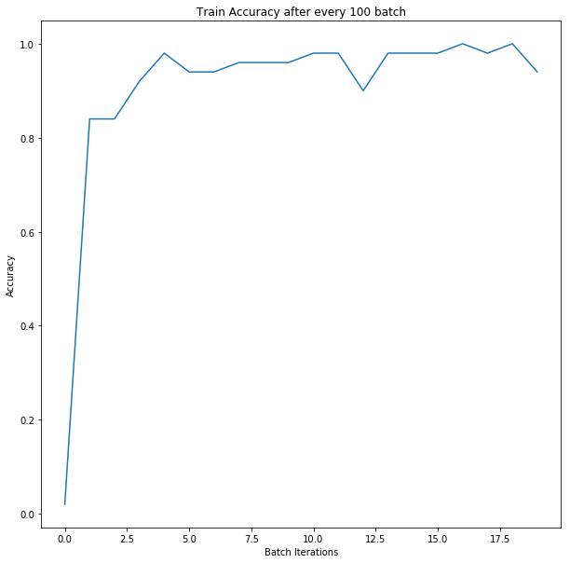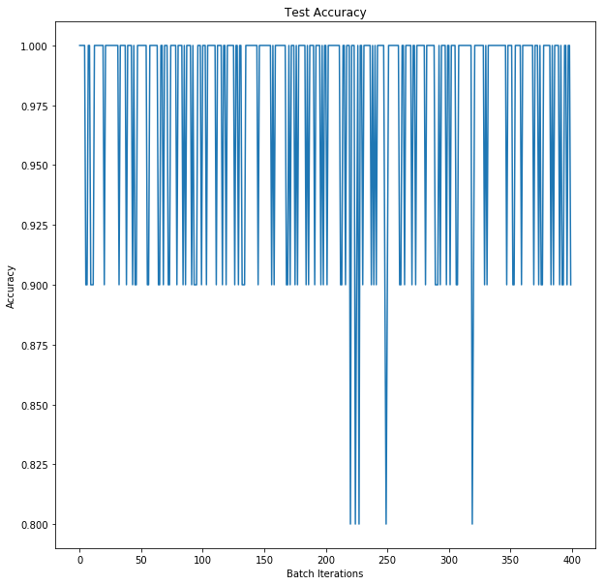  

**Three Convolutional layers**

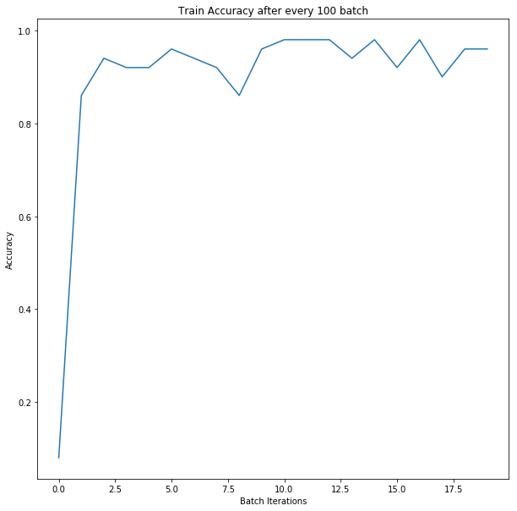 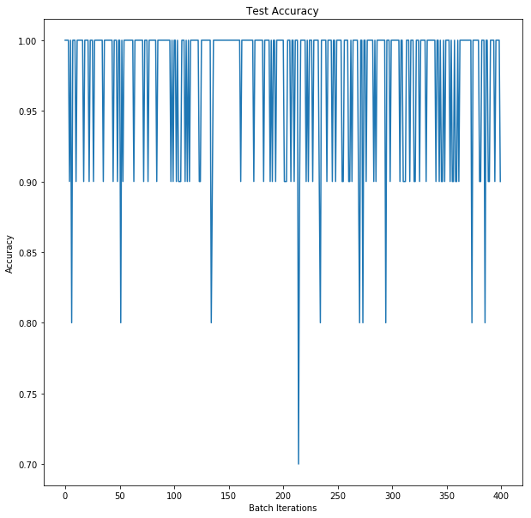

 

Accuracy is optimal in Convolutional with 2 layers. The reason for this is less layers cause underfitting and having more layers can give rise to overfitting. Increase more layers may give more accuracy on the training data but perform poorly on test data.

**2.6**

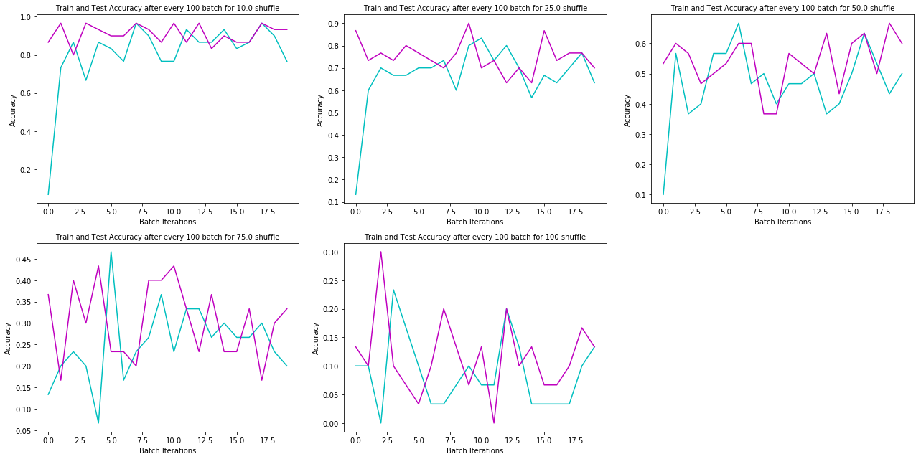

In the above graph testing accuracy is denoted by purple line and training accuracy by blue line.

In case of 100 percent noise, training error is almost double as compared to testing error because there is no noise in testing data as compared to training data. In general, as well test accuracy is more than training accuracy because we are creating shuffling in the training set to introduce noise and the testing data is without any noise.

**References**

[1] "Getting Started | TensorFlow", TensorFlow, 2017. [Online]. Available: https://www.tensorflow.org/get_started/. [Accessed: 14- Nov- 2017].

[2] "Free Image on Pixabay - Gray, Animal, Pet, Cat", Pixabay.com, 2017. [Online]. Available: https://pixabay.com/p-2560716/?no_redirect. [Accessed: 14- Nov- 2017].